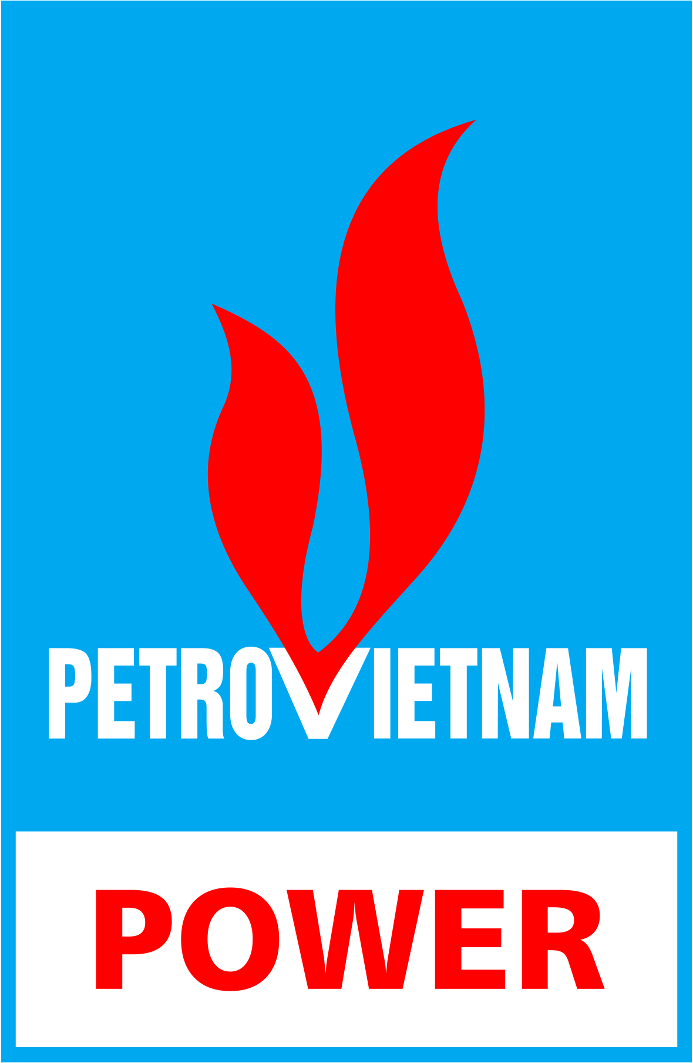 | PETROVIETNAM OIL & GAS GROUP  PETROVIETNAM POWER CORPORATION  DAILY NEWS  Date 31/08/2017

INTERNATIONAL COAL PRICE ASSESSMENTS

Daily prompt physical thermal coal assessments | Window  7 – 45 day | +/- | Window  90 - day | +/-
FOB Newcastle 6,300 GAR | 96.50 | 0.00 | 95.00 | 0.00
CIF ARA 6,000 NAR | 88.60 | +1.10 | 88.30 | +0.30
FOB Richards Bay 5,500 NAR | 72.10 | +0.10 | N/A | N/A
FOB Kalimantan 5,900 GAR | N/A | N/A | 75.60 | +0.50
FOB Kalimantan 5,000 GAR | N/A | N/A | 61.00 | +0.50

China Coal Assessment | USD/tons | +/- | NDT/tons | +/-
PCC6 (CFR South China 3,800 NAR) | 49.25 | +0.15 | 326.82 | +1.04
PCC7 (CFR South China 4,700 NAR) | 66.50 | +0.20 | 441.29 | +1.39
PCC8 (CFR South China 5,500 NAR) | 81.60 | 0.00 | 541.49 | +0.08

DAILY PROMPT PHYSICAL THERMAL COAL ASSESSMENTS IN 2017

(Source: Platts Coal Trader International – Date 25/08/2017)

NEWS
Adani says India still needs coal imported from Australia
Adani chairman Gautam Adani has told an Australian business forum in India his country still needs imported resources, contradicting the Indian Government's policy of coal self-sufficiency. "Imports of high-quality resources to augment domestic mining will be required," Mr Adani said at the conclusion of the Australia-India CEO forum in New Delhi. Adani plans to import 60 million tonnes of coal from Australia each year, from his company's controversial Carmichael mine in Queensland. The company gave the project the go-ahead earlier this year and several days ago Mr Adani said construction would start in October. Stating bluntly that India needs more high-quality coal than it can currently mine runs counter to the policy of India's Government and Prime Minister Narendra Modi, with whom Mr Adani has previously associated. In June this year, Energy Minister Piyush Goyal told a press conference, "We do not wish to import any coal from anywhere in the world. We have sufficient coal capacity," Mr Goyal said. India currently gets almost 59 per cent of its power from coal-fired generators. Government planning documents show although it is rapidly expanding solar and other renewable energy supplies, India will remain primarily reliant on coal for electricity until 2040. Australian environmental groups opposing it have long argued it ought not be built because of questions about its viability. In a separate interview earlier this week, Mr Adani celebrated a recent appeal victory over the Australian Conservation Foundation, which had challenged the Carmichael mine's environmental approval. Mr Adani said he expected it to be producing coal by 2020.
Glencore puts for sale sign on Queensland thermal mine Rolleston
Glencore and its Japanese joint venture partners Itochu and Sumitomo have started a sale process for their Rolleston export thermal coal mine in Queensland's Bowen Basin coal field, said the Australian coal producer in a statement Monday. The Australian coal producer declined to specify a target price for the asset sale, or a preferred completion date. Glencore did stress in its statement: "We will only sell the Rolleston mine if we consider that an offer delivers value for our shareholders," adding that it will be business as usual for the mine during the sales process. Investment bank Merrill Lynch is the sole financial adviser for the sale of Glencore's 75% share in Rolleston, and the 12.5% stakes held by Itochu and Sumitomo, respectively. Explaining its reason for wanting to divest Rolleston from its portfolio of five coal production complexes in Queensland, Glencore said: "This decision is part of Glencore's ongoing program to optimize its portfolio and redeploy capital into other opportunities. The Rolleston mine is a high quality asset that offers potential buyers the opportunity to gain a strong foothold -- or significantly increase their current position -- in the Australian and Queensland coal industry,". In its statement, Glencore said the Rolleston mine was a stable and profitable mine that had recently gained Queensland government approval to continue operating past 2040, and has an experienced management team and a highly skilled workforce. The mine produced 13.3 million mt of thermal coal in 2016. In addition, the mine has an established logistics and transport system and long-term relationships with customers across Asia, said the company.
Glencore has made several changes to its portfolio of coal assets in Australia over recent years. In May this year, its Tahmoor underground mine for coking coal in southern New South Wales was offered for sale, and last year Glencore sold its GRail coal haulage business to US-based Genesee & Wyoming for A$1.14 billion ($906 million). Sumitomo and Glencore purchased a combined 50.1% stake in Clermont, a former Rio Tinto thermal coal mine, through their 50:50 owned company GS Coal Proprietary Limited for $1.015 billion, said Rio Tinto in a June 2014 statement. Sumitomo Corporation acquired a 25.05% interest in Clermont, and the Japanese company through its Sumisho Coal Australia subsidiary has mining rights for four Australian coal mines, the company said on its website. Glencore is the operator for Clermont and has a 25.05% stake in the mine that produced 12.5 million mt/year of saleable export coal, according to the company's website. Japanese companies Mitsubishi (31.4%), J-Power (15%) and JCD Australia (3.5%) are the other joint venture partners in the Clermont open-pit mine which exports through Dalrymple Bay coal terminal. Itochu Corporation, the other joint venture partner in Rolleston, has interests in four operational coal mines in Australia including Glencore's Oaky Creek and Ravensworth mines. Glencore's five coal mining complexes in Queensland -- Clermont, Collinsville, Newlands, Oaky Creek and Rolleston -- together produced 40 million mt of coal in 2016 and employ 2,560 people, said Glencore in its statement.
Coal development plan announced
Prime Minister Nguyễn Xuân Phúc recently approved the adjustment and supplementation of the Việt Nam coal industry development plan until 2020, with a vision towards 2030. Accordingly, the coal sector will invest in constructing new coal sorting factories by 2020, namely Vàng Danh 2, Khe Than, Khe Chàm and Lép Mỹ, with annual capacity of two million tonnes, 2.5 million tonnes, seven million tonnes and four million tonnes, respectively. In addition, a centralised coal processing and warehouse centre will be built in the Hòn Gai region with capacity of some five million tonnes per year. The first module with annual capacity of 2.5 million tonnes in Hà Khánh Commune will be built and operation of the Nam Cầu Trắng coal sorting factory will be maintained until the end of 2018. The factory will then be moved to the location of the centralised coal processing and warehouse centre to be installed as the second module with capacity of 2.5 million tonnes per year. The categories of some small-scale projects in the mines of Vàng Danh, Năm Mẫu, Suối Lai and Cọc Sáu, as well as Đèo Nai, Lộ Trí and Mông Dưong, will also be amended, alongside the categories of a number of infrastructure investment projects that serve coal industry development.
Earlier, under Decision No 403/QĐ-TTg, dated March 14, 2016, the PM ratified the adjustment of the development plan of Việt Nam’s coal industry until 2020 with a vision towards 2030, with the view to building the coal sector into a developed industry with high competitiveness and advanced technological standards in comparison with regional countries with regard to the steps of coal exploration, mining, sort out, processing and use, sufficiently satisfying domestic coal demand, especially for power generation. A report from the Việt Nam National Coal and Mineral Industries Group (Vinacomin) revealed that in the first half of this year, coal output was estimated at some 20.6 million tonnes while coal inventory was 9.3 million tonnes. The inventory is expected to be higher as the PM required Vinacomin to produce additional two million tonnes to contribute to the country’s GDP growth rate this year.

(Source: Platts)
INTERNATIONAL SPOT DRY BULK FREIGHT ASSESSMENTS
Unit: USD/ton
Size | From | To | Freight rates | Change
Capesize | Australia | China | 8.65 | +0.40
(150,000 tons) | Queensland | Japan | 9.45 | +0.40
 | New South Wales | South Korea | 9.70 | +0.40
Panamax | Richards Bay | India West | 11.65 | 0.00
(70,000 tons) | Kalimantan | India West | 8.00 | 0.00
 | Richards Bay | India East | 11.00 | 0.00
 | Kalimantan | India East | 6.95 | 0.00
 | Australia | China | 10.60 | 0.00
 | Australia | India | 12.15 | 0.00
(Source: Platts Coal Trader International – Date 25/08/2017)

