PETROVIETNAM OIL & GAS GROUP
PETROVIETNAM POWER CORPORATION
WEEKLY NEWS – FIFTH WEEK OF NOVEMBER
(From 27/11 – 1/12/2017)

- COAL MARKET ANALYSIS
1. INTERNATIONAL COAL PRICE ASSESSMENTS
Unit: USD/ton
Price index | Week  06/11-10/11 | Week  13/11-17/11 | Week  20/11-24/11 | Week  27/11-01/12
PCC 6  (CFR South China 3,800 NAR) | 52.74 | 50.94 | 50.98 | 51.58
PCC 7  (CFR South China 4,700 NAR) | 73.06 | 71.00 | 70.58 | 70.86
PCC 8  (CFR South China 5,500 NAR) | 87.46 | 84.70 | 83.50 | 83.82
FOB Newcastle 6,300 GAR | 97.26 | 94.18 | 91.74 | 94.92
CIF ARA 6,000 NAR | 95.03 | 94.86 | 92.97 | 92.63
FOB Richards Bay 6,000 NAR | 77.01 | 75.05 | 74.15 | 78.20
NEWC  (FOB Newcastle 6,000 NAR) | 98.99 | 96.32 | 91.91 | 96.24

Chart 1: Average coal price week 5th November (2017)
(Source: Platts Coal Trader International)

2. INTERNATIONAL SPOT DRY BULK FREIGHT ASSESSMENTS
Unit: USD/ton
 | Week 5th - November | 27/11 | 28/11 | 29/11 | 30/11 | 01/12
 | Capesize (150,000 tons)
1 | Australia – China | 11.25 | 11.45 | 11.45 | 11.85 | 11.85
2 | Queensland – Japan | 12.95 | 13.15 | 13.15 | 13.55 | 13.40
3 | New South Wales – South Korea | 13.30 | 13.50 | 13.50 | 13.90 | 13.75
 | Panamax (70,000 tons)
1 | Richards Bay - India West | 12.25 | 12.25 | 12.25 | 12.25 | 12.25
2 | Kalimantan - India West | 8.60 | 8.65 | 8.65 | 8.75 | 8.75
3 | Richards Bay - India East | 12.60 | 12.60 | 12.60 | 12.60 | 12.60
4 | Kalimantan - India East | 7.25 | 7.25 | 7.25 | 7.35 | 7.35
5 | Australia - China | 11.60 | 11.60 | 11.65 | 11.65 | 11.75
6 | Australia - India | 13.00 | 13.00 | 13.00 | 13.20 | 13.40
(Source: Platts Coal Trader International)
- NEWS
Turkey October steam coal imports up 14.7% year on year to 3.4 million mt
Turkey imported 3.4 million mt of steam coal in October, up 14.7% year on year and 22.1% month on month, according to foreign trade data Thursday.
Turkey thermal coal imports
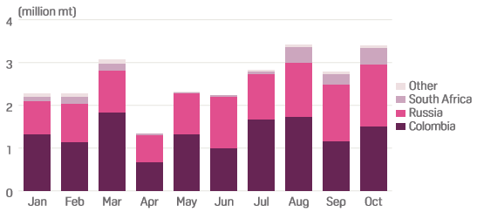
(Source: Turkey Foreign Trade Statistics)
Colombia was the biggest exporter to Turkey in October, with a total volume of 1.5 million mt shipped for the month, up 28% year month on month and 5% year on year. Russia was a close second, exporting 1.45 million mt, up 10% month on month and 6% year on year. That was the largest volume exported to Turkey from Russia since S&P Global Platts began collecting the data in January 2013. South African exports to Turkey for October stood at 393,410 mt, up 63% month on month and was the highest volume exported from South Africa to Turkey since March 2016.
Bumi resources Jan-Sep coal output down 0.9% on-year
Bumi Resources, Indonesia’s largest thermal coal miner, said Monday it produced 21.9 million mt of coal in July-September 2017, making Jan-Sept output down 0.9% year on year at 62.1 million mt. Bumi averaged a selling price in July-September 2017 of $58/mt FOB, and its average price in October was $59.40/mt, a company source said Monday.
For the January-September 2017 period, Bumi achieved an average selling price of $55.90/mt FOB, up from $40.10/mt for the corresponding 2016 period, the company said in a report. Bumi has majority equity stakes in major Indonesian coal producers Kaltim Prima Coal and Arutmin, which both produce steam coal with a heating value of 4,200-7,100 kcal/kg GAR, according to Bumi’s website. The 90-day price of FOB Kalimantan 5,900 kcal/kg GAR has climbed 15.7% to date in 2017, according to S&P Global Platts data. The 90-day price of FOB Kalimantan 5,000 kcal/kg GAR has risen 15.3% to date this year and the 90-day price of FOB Kalimantan 4,200 kcal/kg GAR is up about 20.8% to date, Platts data showed.
South Africa exports 6.92 million mt thermal coal October
South Africa thermal coal exports totaled 6.92 million mt in October, down 13.7% from September’s year-to-date high figure but up 12.6% year on year, customs data showed Thursday.
South Africa thermal coal exports
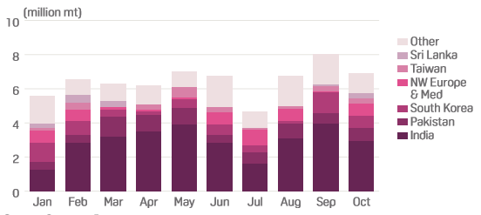
(Source: Customs Data)
India was the single biggest export destination, receiving 2.96 million mt, down 6% year on year and 26% from September’s figure of nearly 4 million mt. Pakistan imported 737,142 mt October, up 22% month on month and 136% year on year as it continued to show a strong thirst for South African coal. South Korea imported 720,000 mt, down 42% from September’s record 1.24 million mt, but up 68% year on year and well above the monthly average of 611,945 mt.
Imports to Northwest Europe and the Mediterranean reached a year-to-date high of 712,655 mt, up 17-fold month on month and 146% year on year. Key import terminals in the Netherlands and Spain contributed 486,655 mt and 171,000 mt, respectively. Exports to Taiwan were 322,500 mt, up 18% month on month and 115% year on year, while exports to Sri Lanka were 301,150 mt, up 122% month on month and 26% year on year.
Kospo tenders for 640,000 mt of thermal coal
Korea Southern Power (Kospo) announced Thursday a tender seeking 640,000 mt of thermal coal for loading in January to February 2018 and for delivery to its Samcheok power plant. In the tender KOSPO-Coal-2017-SC-EST23, the utility seeks eight 80,000 mt, Panamax shipments of thermal coal with a minimum calorific value of 3,700 kcal/kg net as received, maximum total moisture of 43% as received, 16%-45% volatile matter air dried, maximum 4.5% ash air dried, and maximum 0.35% sulfur as received. Kospo asked for the first four cargoes to be loaded in January and the rest in February. Offers must be on single, fixed free-on-board-and-trimmed (FOBT) basis. The tender closes on December 4.
(Source: Platts)

